Training the Brain to Learn: Beyond Vision Therapy
Kenneth Gibson, O.D.
Dick Carpenter, PhD
Amy Lawson Moore, MA, PhD Candidate
Tanya Mitchell, BA

Tables: 3
Figures: 5

Corresponding Author:
Amy Lawson Moore
Gibson Institute of Cognitive Research
5085 List Drive, Suite 220
Colorado Springs, CO 80919
719-219-0940 phone
719-522-0434 fax
amoore@gibsonresearch.org
Submitted January 29, 2015

Training the Brain to Learn: Beyond Vision Therapy
According to The Nation’s Report Card in 2013, only 38% of students could read at or above the level of “proficient”; and less than 40% of graduating high school seniors were predicted to be academically prepared for college¹. Although only 5% of students in the United States are officially diagnosed with learning disabilities², these numbers indicate that many more students are struggling in school. Practitioners in the field of visual therapy are continually challenged with finding effective interventions to minimize the impact of learning problems among their patients³.
Like conducting an orchestra, learning is a complex act requiring the execution of simultaneous cognitive processes that each contribute to various aspects of learning. For example, visual processing is the ability to perceive, analyze, and think in images. If a student struggles with visual imagery, tasks like math word problems and reading comprehension are difficult. Auditory processing is the ability to perceive, analyze, and conceptualize what is heard. If a student struggles with blending, segmenting, or analyzing sounds, reading and spelling skills will be impacted. Attention includes the ability to stay on task, to ignore distractions, and to handle multiple tasks simultaneously—all which contribute to academic success. Working memory is the ability to capture and retain information for short periods of time while simultaneously using it; and long-term memory is the ability to recall information that was learned in the past. A student’s ability to produce correct responses or draw accurate conclusions is impacted if his ability to store or retrieve information is weak.
Together, these and other cognitive processes such as processing speed and fluid reasoning enable us to analyze, evaluate, retain information, recall experiences, make comparisons, and determine action. For example, in order to read, a child must visually process the letters and words as well as simultaneously recall and associate those visual images with sounds. At the same time, the child must mentally associate the words with meaning. A deficit in just one cognitive skill may limit the efficiency of the child’s brain to process information on the page.
Several cognitive skill deficits have been identified as contributors to reading and learning difficulty. Although deficits in auditory processing are frequently associated with poor reading ability⁴, deficits in visual attention⁵, visual memory⁶, and visual motor integration^{7,8} have also been identified. Further, research on both children and adults with reading disabilities has revealed deficits in working memory⁹ and processing speed¹⁰, the ability to perform automatic cognitive tasks.
Research also suggests that visual processing interventions have successfully improved targeted cognitive skills necessary for learning. For example, visual attention therapy improved reading comprehension scores among a group of 6th grade students with moderate reading disabilities¹¹. In addition, studies by Center¹² and Brown¹³ reported statistically significant correlations between visualization training and reading comprehension scores of students when used as part of a multiple-strategy instruction intervention.
Working memory interventions have also been successful in enhancing the skills needed for learning. Working memory is responsible for managing the process of extracting information from text and integrating it with prior knowledge to create meaning¹⁴. In a study of both skilled readers (n = 50) and dyslexic readers (n = 41), improvements were noted in decoding, fluency rate, and comprehension for both groups following direct training of working memory¹⁵. In a recent article in Optometry and Visual Performance, Groffman¹⁶ also noted the importance of integrating working memory training techniques in optometric vision therapy practices.
Targeted training in logic and reasoning may also help students process information better. Logic and reasoning is the ability to solve problems using unfamiliar information or novel procedures. The process of inferential reasoning requires both short-term and long-term memory, and acting on retrieval of background knowledge combined with the text to arrive at implicit information¹⁷. In one study, children trained in reasoning skills increased their IQ by an average of 10 points¹⁸.
Given the success of such targeted interventions at remediating individual cognitive skills, is it easy to see the impetus to develop a therapeutic model to address remediation of multiple cognitive skills. This study addresses the effectiveness of such a model that can be used as part of a visual therapy practice. Pediatric optometrist Ken Gibson developed a comprehensive cognitive training intervention called ThinkRx¹⁹, a revised version of the Processing and Cognitive Enhancement (PACE) program used by over 600 clinicians to augment their visual therapy, occupational therapy, audiology, speech therapy, and psychology practices. The program is based on Gibson’s Learning Model (Figure 1), a schematic of how information is processed.
The Learning Model²⁰ is grounded in the Cattell-Horn-Carrol (CHC) theory of intelligence which describes thinking as a set of seven broad abilities: comprehension knowledge, long-term retrieval, visual-spatial thinking, auditory processing, fluid reasoning, processing speed, and short-term memory²¹. According to the Learning Model, a child takes information in through the senses (input) that must be recognized and analyzed by the active processing system (working memory, processing speed, attention). This executive control system determines which information is unimportant, easily handled, or requires thinking. Unimportant information is discarded from working memory. If the input contains important information about data that has already been stored in the knowledge bank, it is quickly retrieved and converted to output such as speaking or writing. If the information has not been previously stored, higher thinking processes must then occur. Reasoning, auditory processing, and visual processing must be used to solve the problem or complete the task. If the task is practiced often enough, however, the information is stored in the knowledge bank which will decrease the time between input to output. This occurs because the higher thinking processes can then be bypassed.
The ThinkRx cognitive training program targets and remediates the seven primary cognitive skills and multiple sub-skills through repeated engagement in game-like mental tasks delivered one-on-one by a clinician or cognitive trainer. The tasks emphasize visual or auditory processes that require attention and reasoning throughout each 60 to 90 minute training period. Using a synergistic “drill for skill” and meta-cognitive approach to developing cognitive skills, the program incorporates varying levels of intensity, hierarchical sequencing of tasks, multiple task loading, and instant feedback from the clinician. Training sessions are focused, demanding, intense, and tightly controlled by the clinician to push students to just above their current cognitive skill levels. Deliberate distractions are built in to the sessions to tax the brain’s capacity for sorting and evaluating the importance of incoming information. This ability to correctly handle distracting information and interruptions is the foundation for focus and attention skills²⁰.
Consisting of 23 different procedures with over 1000 total difficulty levels, the 60-hour ThinkRx program serves as the foundation for the LearningRx cognitive skills training system, and is often used in combination with an additional 60 hours of an intensive sound-to-code reading intervention, called ReadRx²². The addition of ReadRx gives clinicians more procedures to deliver that focus on auditory processing, basic code, and complex coding skills necessary to improve reading rate, accuracy, fluency, comprehension, spelling, and writing. The interventions are delivered over the course of twelve to twenty-four weeks. The following training procedures are examples of multiple-skill targeting in the cognitive training program.
Procedure 1: Memory Match
Memory Match (Figure 2) engages and develops visual memory, visual discrimination, and visual span; as well as processing speed and sustained attention. Using matching workboards with six squares each, the clinician randomly arranges cards containing cones, rings, or boxes into a pattern that the student may study for three seconds. After the clinician covers his workboard, the student must reproduce the same pattern on his own workboard while simultaneously counting aloud to the beat of a metronome. There are nine progressively more difficult levels for this procedure with 34 total variations.
Procedure 2: Reasoning Brain Cards
The Reasoning Brain Cards (Figure 3) cognitive training task targets logic and reasoning, visual discrimination, processing speed, working memory, selective and sustained attention, and comprehension. The clinician randomly arranges a set of 9 or 12 cards, each with four characteristics: shape, color, size, and orientation. The student must identify a group of three cards that shares one of the characteristics. For example, a group of three cards may all contain a medium-sized shape. There are 10 progressively more difficult levels with 40 variations of the task.
Procedure 4: Attention Speed
Attention Speed targets working memory, processing speed, attention, saccadic fixation, visual discrimination, visual span, and sensory-motor integration (Figure 4). On a grid of 144 similarly-shaped letters (p, d, b, q), the student may be asked to circle every p, cross out every d, draw a triangle around every b, and draw a square around every q while counting to every beat on the metronome and racing the stopwatch. There are 11 levels and 44 variations of this procedure, including visual discrimination of numbers as well.
Procedure 5: Reading Pictures
Reading Pictures is a training task that integrates visual and auditory processing skills, and targets the underlying reading and spelling skills of blending, segmenting, and auditory analysis. Early and struggling readers are trained in the use of visual images to help them remember the alternative spellings for the same sounds. In the example (Figure 5), the ‘ou’ in cloud shares the same sound /ou/ as the ‘ow’ in cow. The larger of the images indicates the more common spelling of the sound.
The purpose of the current study was to evaluate the effectiveness of ThinkRx/ReadRx cognitive training by examining the change in cognitive skills of students who completed the training program compared to students who did not. Given the pretest to post-test changes documented in unpublished clinical results reports for over 7000 students prior to the study²³, we hypothesized that children who received cognitive training would achieve greater cognitive skills improvements than children who did not receive cognitive training.
METHODS
Participants
Sixty-one students (ages 6-18) were selected for inclusion in the study. The treatment group (n = 31) included students who had completed 24 weeks of cognitive training at brain training center in Colorado Springs. There were 20 males and 11 females with a mean age of 11.2. In the treatment group, fourteen participants entered the program with a diagnosed learning disability. The control group (n = 30) was a cohort of propensity-matched children who had pretested but did not enroll in the cognitive training program. There were 21 males and 9 females with a mean age of 10.1; and eleven participants had been previously diagnosed with a learning disability. Permission to conduct the study was granted by the LearningRx Scientific Advisory Board. Informed consent and assent were obtained from parents and children, respectively. Participants in the control group received a gift card to a local store as compensation for returning for post-testing.
Measures
All participants were pretested and post-tested by a clinician or certified cognitive trainer using the Woodcock Johnson III – Tests of Cognitive Abilities and Tests of Achievement²⁴. The psychometric properties of the Woodcock Johnson III (WJ-III) have been extensively researched, and it is considered an accurate assessment of cognitive skill development. The test was normed on 8,818 subjects, with reliability coefficients of .80 and above and concurrent validity correlations of .67 to .76²⁵. For this study, the specific test batteries used to measure the seven primary cognitive skills included visual-auditory learning, spatial relations, concept formation, numbers reversed, pair cancellation, word attack, and sound awareness (Table 1).
RESULTS
Independent Samples t Tests
Difference scores from pretest to post-test were calculated for each test battery (Table 2). The treatment group achieved large positive gains across all cognitive skills tested; and the control group achieved losses in working memory and word attack scores while making only small positive gains on the remaining tests. After Bonferroni correction of the alpha level to .01, independent samples t tests indicated statistically significant differences between the treatment and control groups on visual-auditory learning (t(59) = -5.51, p < .001); concept formation (t(59) = 3.89, p < .001); numbers reversed (t(59) = 4.35, p < .001); pair cancellation (t(59) = 4.87, p < .001); Word Attack (t(59) = 5.32, p < .001); and sound awareness (t(59) = 5.35, p < .001); as well as a nearly significant difference in spatial relations (t(59)= 2.10; p = .04)
Multiple Linear Regression
Multiple regression (MR) analyses were conducted to examine if membership in the treatment group predicted greater gains in scores for students. Three common predictors of academic differences—age, gender, and learning disability—were also included as independent variables. The dependent variable in each regression model was the difference score between each cognitive pretest and post-test. Results indicated that treatment group membership was a significant predictor of greater gains from pretest to post-test across measures of long-term memory, logic and reasoning, working memory, processing speed, auditory processing, and Word Attack skills (Table 3). Age, gender, and learning disability did not have significant contributions to the variances in scores.
Long-term memory. MR analysis to predict long-term memory outcomes indicated that pretest to post-test gains on the Visual-Auditory Learning test were 13.4 points higher for the treatment than the gains for the control group. The overall analysis of variance was statistically significant (F (4, 56) = 11.20, p < .001) with a large effect size (R² = .445). The overall regression model accounted for 44.5% of variance in scores; and examination of individual predictor variables indicated that almost 28% (sr² = .281) of the variance in long-term memory was explained by group membership.
Visual processing. MR analysis to predict outcomes in visual processing indicated that pretest to post-test gains on the Spatial Relations test were 4.9 points higher for the treatment group than the gains for the control group. The overall analysis of variance was statistically significant (F (4, 56) = 3.79, p =.008) with a medium effect size (R² = .213). The overall regression model accounted for 21.3% of variance in scores; no individual predictor variables were significant.
Logic and reasoning. Training outcomes in logic and reasoning were analyzed with MR analysis of the pretest to post-test difference scores on the Concept Formation test. The overall analysis of variance was statistically significant (F (4, 56) = 4.26, p = .004) with a medium effect size (R² = .233). The overall regression model accounted for 23.3% of the variance in scores; and 18.4% (sr² = .184) was explained by group membership. The treatment group gains were 9.34 points greater than the control group.
Working memory. MR analysis to predict working memory outcomes indicated that pretest to post-test gains on the Numbers Reversed test were 13.9 points higher for the treatment than the gains for the control group. The overall analysis of variance was statistically significant (F (4, 56) = 5.04, p = .002) with a large effect size (R² = .265). The overall regression model accounted for 26.5% of variance in scores; and examination of individual predictor variables indicated that almost 21% (sr² = .207) of the variance in working memory gains was explained by group membership.
Executive processing speed. Training outcomes in executive processing speed were analyzed with MR analysis of the pretest to post-test difference scores on the Pair Cancellation test. The overall analysis of variance was statistically significant (F (4, 55) = 9.53, p < .001) with a large effect size (R² = .409). The overall regression model accounted for 41% of the variance in scores; and 24.5% (sr² = .245) was explained by group membership. The treatment group gains were 11.3 points greater than the control group gains.
Word Attack. MR analysis to predict Work Attack outcomes indicated that pretest to post-test gains on the Word Attack test were 12.3 points higher for the treatment than the gains for the control group. The overall analysis of variance was statistically significant (F (4, 56) = 7.84, p < .001) with a large effect size (R² = .359). The overall regression model accounted for 36% of variance in scores; and examination of individual predictor variables indicated that 28.1% (sr² = .281) of the variance in Word Attack gains was explained by group membership.
Auditory processing. Training outcomes in auditory processing were analyzed with MR analysis of the pretest to post-test difference scores on the Sound Awareness test. The overall analysis of variance was statistically significant (F (4, 56) = 7.59, p < .001) with a large effect size (R² = .352). The overall regression model accounted for 35.2% of the variance in scores; and 28.4% (sr² = .284) was explained by group membership. The treatment group gains were 15.9 points greater than the control group gains.
DISCUSSION
The purpose of this study was to examine the effectiveness of the ThinkRx/ReadRx cognitive training program for students with learning problems. The results of the analyses indicated that students who completed the cognitive training program realized greater gains than the control group across all measures. Statistically-significant differences were noted in six of the seven sets of scores measuring long-term memory, logic and reasoning, working memory, executive processing speed, auditory processing, and Word Attack. The results are consistent with previous findings that direct training of individual cognitive skills increases functioning in the trained area^{4,12,13,14,15,18}. However, this is the first study to document significant improvements in six cognitive skills following comprehensive, one-on-one cognitive training. This is a critical addition to the literature given the multivariate nature of skills needed for learning and reading²⁶.
Further, membership in the treatment group was a significant predictor of pretest to post-test gains on the same six skills. Although an association between age and long-term memory was approaching significance, the examination of individual predictors of score gains revealed no significant association with age, gender, or learning disability in any of the measures. One interesting finding is the consistency of gains for all students in the treatment group regardless of learning disability status. That is, both students with a prior learning disability diagnosis as well as those without a diagnosis made significant gains. This finding indicates that cognitive training may be appropriate for all types of struggling students, and not an intervention limited to students with LD diagnoses. A similar finding that age and gender did not influence outcomes for students in the treatment group also widens the potential application of cognitive training. The interventions may be appropriate for students at any age and for either gender.
It is interesting to note that the only non-significant difference between the treatment and control groups was on the Spatial Relations test, a measure of visual processing. Although gains were higher in the treatment group (M = 8.77) than the control group (M = 3.33), both groups realized gains from pretest to post-test. Perhaps this is due to the developmental nature of visual processing skills on a continuum of natural progression through adolescence²⁷, and associated maturation effects during the 24-week period between pretesting and post-testing. An alternative explanation, however, may be that the exercises delivered by clinicians were focused more heavily on the auditory processing, memory, reasoning, and executive processing skills necessary for reading and learning. This focus is a key component of the ReadRx and ThinkRx programs. A clinical implication of this finding is that the cognitive training procedures use in this study may indeed complement an existing visual therapy paradigm to maximize outcomes in all areas for struggling learners.
A limitation of the study was the lack of randomization of participants. Participants in the treatment group self-selected into the cognitive training program. However, the control group participants were selected through propensity matching, a procedure which helps mitigate the effects of non-randomization. Further, the use of difference (gain) scores in multiple regression analysis controlled for any differences among students’ pretest scores. Future studies should incorporate randomization and a larger sample size, but the findings from the current study are encouraging for the use of comprehensive cognitive training in the remediation of multiple cognitive skills necessary for learning.

References
- US Department of Education, Institute of Education Sciences, National Center for Education Statistics, National Assessment of Educational Progress. 2013 Mathematics and Reading: Grade 12 Assessments. Available at http://www.nationsreportcard.gov/reading_math_g12_2013/ . Accessed January 28, 2015.
- Cortiella C, Horowitz SH. The State of Learning Disabilities: Facts, Trends, and Emerging Issues. New York: National Center for Learning Disabilities; 2014
- Garzia RP, Borsting EJ, Nicholson SB, Press LJ, Scheiman MM, Solan HA. Optometric Clinical Practice Guideline: Care of the Patient with Learning Related Vision Problems. St. Louis: American Optometric Association; 2010.
- Tanaka H, Black JM, Hulme C, Stanley LM, Kesler SR, Whitfield-Gabrielli S, Reiss AL, Gabrielli JDE, Hoeft F. The brain basis of the phonological deficit in dyslexia is independent of IQ. Psy Sci 2011; 22:1442-1451.
- Rajaram V. Visual attention deficits in reading disability. Optom Vis Sci 2013; 1:141-147.
- Taylor Kulp M, Edwards KE, Mitchell GL. Is visual memory predictive of below-average academic achievement in second through fourth graders? Optom Vis Sci 2002; 79:431-435.
- Barnhardt C, Borsting E, Deland P, Pham N, Vu T. Relationship between visual-motor integration and spatial organization of written language and math. Optom Vis Sci 2005; 82:E138-E143.
- Kulp MT, Sorter MJ. Clinical value of the Beery visual-motor integration supplemental tests of visual perception and motor coordination. Optom Vis Sci 2003; 80: 312-315.
- Cohen-Mimran R, Sapir S. Auditory temporal processing deficits in children with reading disabilities. Dyslexia 2007; 13:175-92.
- Peter B, Matsushita M, Raskins WH. Global processing speed in children with low reading ability and in children and adults with typical reading ability: exploratory factor analytic models. J Speech Lang Hear Rsch 2011; 54: 885-99.
- Solan HA, Larson S, Shelley-Tremblay J, Ficarra A, Silverman M. Role of visual attention in cognitive control of oculomotor readiness in students with reading disabilities. J Learn Dis 2003; 34:107-118.
- Center Y, Freeman L, Robertson G, Outhred L. The effect of visual imagery training on the reading and listening comprehension of low listening comprehenders in Year 2. J Rsch Read 1999; 22: 241-256.
- Brown R, Pressley M, Van Meter P, Schuder T. (1996). A quasi-experimental validation of transactional strategies instruction with low-achieving second grade readers. J Ed Psy 1996; 88: 18-37.
- García-Madruga JA, Elosúa M, Gil L, Gómez-Veiga I, Vila J, Orjales I,... Duque G. Reading comprehension and working memory's executive processes: An intervention study in primary school students. Read Rsch Quart 2013; 48: 155-174.
- Shiran A, Breznitz Z. The effect of cognitive training on recall range and speed of information processing in the working memory of dyslexic and skilled readers. J Neuroling 2011; 24:524-37.
- Groffman S. Working memory: theory, deficits, diagnosis, and vision therapy. Opt Vis Perf 2014; 2:268-279.
- Kispal A. Effective teaching of inference skills for reading: literature review. [Research report No DCSF-RR031] National Foundation for Educational Research 2008. Available at http://files.eric.ed.gov/fulltext/ED501868.pdf . Accessed January 29, 2015.
- Mackey AP, Hill SS, Stone SI, Bunge SA. Differential effects of reasoning and speed training in children. Dev Sci 2011; 14:582-90.
- Gibson K, Mitchell T, & Tenpas D. ThinkRx. Colorado Springs: LearningRx; 2003.

- Gibson K, Hanson K, Mitchell T. Unlock the Einstein Inside: Applying New Brain Science to Wake up the Smart in Your Child. Colorado Springs: LearningRx; 2007.
- McGrew, KS. The Cattell-Horn-Carroll theory of cognitive abilities. In: Flanagan DP, Harrison PL, eds. Contemporary Intellectual Assessment: Theories, Tests, and Issues. New York: Guilford Press; 2005: 136–81.
- Gibson K, Hanson K, Mitchell T, Tenpas, D. ReadRx: Sound to Code Reading and Spelling Program. Colorado Springs: LearningRx; 2003.

- LearningRx Results Reports: 2004-2011. Available at http://www.learningrx.com/results . Accessed January 29, 2015.
- Woodcock RW, McGrew KS, Mather N. Woodcock-Johnson III. Itasca, IL: Riverside Publishing; 2001.
- McGrew KS, Schrank FA, Woodcock RW. Woodcock-Johnson III Normative Update. Rolling Meadows: Riverside Publishing; 2007.
- Evans JJ, Floyd RG, McGrew KS, Leforgee MH. The relations between measures of Cattell-Horn-Carrol (CHC) cognitive abilities and reading achievement during childhood and adolescence. School Psy Rev 2002; 31: 246-62…
- Seassau M, Bucci MP. Reading and visual search: a developmental study in normal children. PLOS One 2013; 8(7): 1-11. Available at http://www.plosone.org/article/info%3Adoi%2F10.1371%2Fjournal.pone.0070261 . Accessed January 28, 2015.

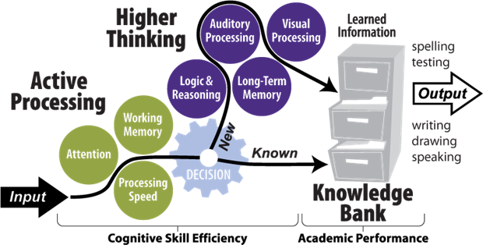

Figure 1. The Learning Model

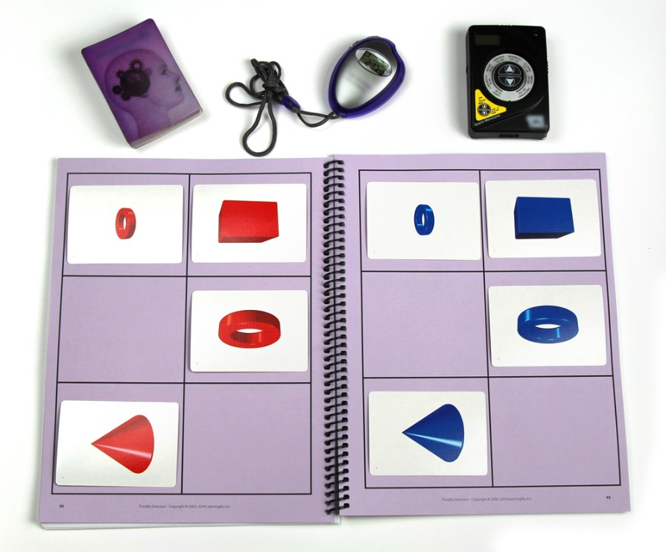

Figure 2. Memory Match Cognitive Training Procedure

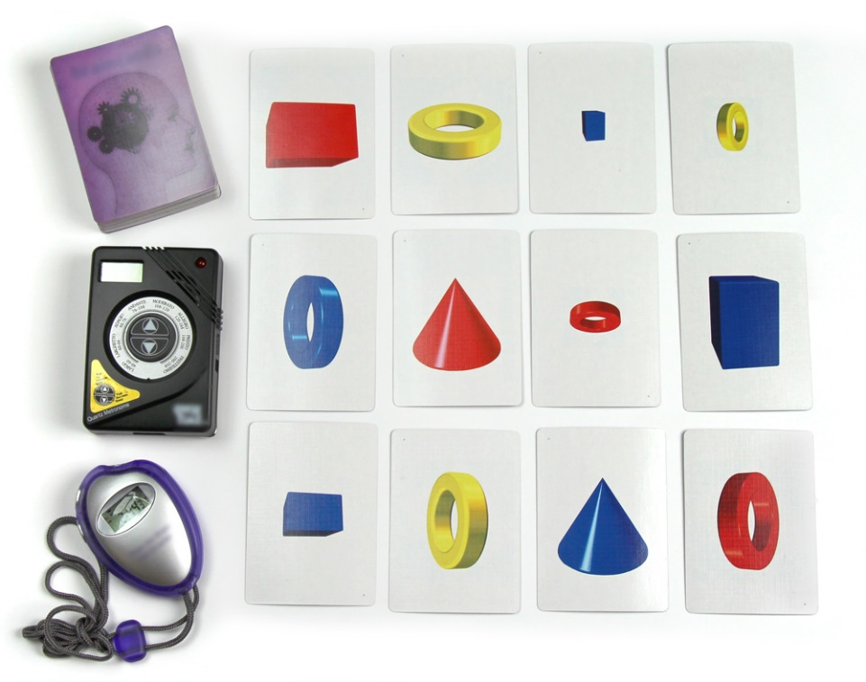
Figure 3. Reasoning Braincards Cognitive Training Procedure

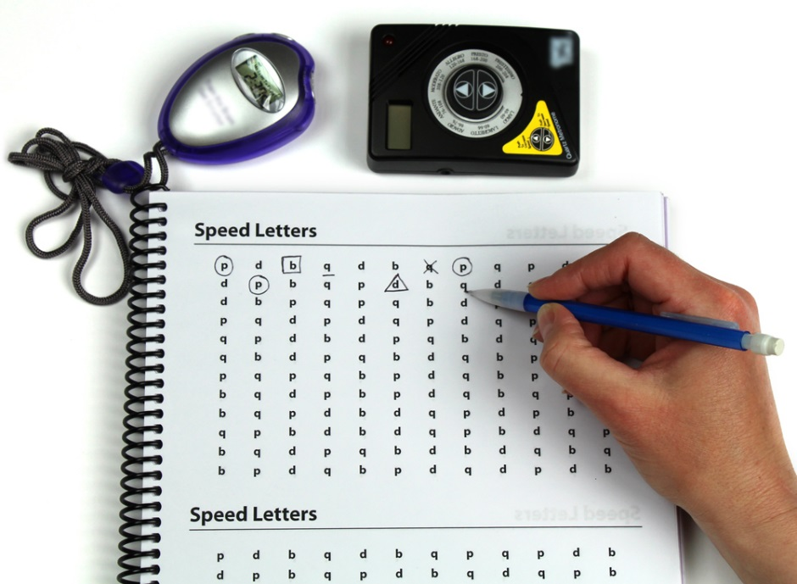

Figure 4. Attention Speed Cognitive Training Procedure

Figure 5. Reading Picture Cognitive Training Procedure

Table 1. Woodcock Johnson III Test Descriptions

Test No. | Test Name | Skill Measured | Description
COG 2 | Visual-Auditory Learning | Long-Term Memory | Learn and recall the meaning of rebuses
COG 3 | Spatial Relations | Visual Processing | Identify individual pieces that form a completed shape
COG 5 | Concept Formation | Logic & Reasoning | Derive a rule from a presented stimulus set
COG 7 | Numbers Reversed | Working Memory | Perform an operation on numbers held in working memory
COG 20 | Pair Cancellation | Processing Speed | Locate and mark a repeated pattern quickly
ACH 13 | Word Attack | Word Attack | Produce letter sounds and read nonsense words aloud
ACH 21 | Sound Awareness | Auditory Processing | Rhyme, delete, substitute, and reverse words or word parts

Table 2: Mean Difference from Pretest to Post-test by Treatment Group

Test | Group | n | Pretest (SD) | Post-test (SD) | Difference (SD)
WJ III COG 2:  Visual-Auditory Learning | Control | 30 | 99.17 (10.72) | 103.90 (11.51) | 4.73 (11.03)
 | LearningRx | 31 | 92.07 (8.54) | 111.75 (11.41) | 19.70 (10.17)
WJ III COG 3:  Spatial Relations | Control | 30 | 105.07 (9.38) | 108.40 (10.53) | 3.33 (8.62)
 | LearningRx | 31 | 100.68 (11.20) | 109.68 (7.75) | 8.77 (11.35)
WJ III COG 5:  Concept Formation | Control | 30 | 107.73 (14.05) | 109.97 (10.73) | 2.23 (10.56)
 | LearningRx | 31 | 104.71 (12.62) | 115.64 (12.93) | 11.87 (8.62)
WJ III COG 7:  Numbers Reversed | Control | 30 | 98.07 (12.09) | 96.83 (10.81) | -1.23 (12.01)
 | LearningRx | 31 | 96.00 (17.31) | 108.36 (15.83) | 13.48 (14.25)
WJ III COG 20:  Pair Cancellation | Control | 30 | 98.67 (11.66) | 104.57 (11.72) | 5.90 (8.64)
 | LearningRx | 31 | 96.59 (13.74) | 113.71 (15.55) | 17.90 (10.33)
WJ III ACH 13:  Word Attack | Control | 30 | 104.50 (9.83) | 102.47 (11.83) | -2.03 (9.32)
 | LearningRx | 31 | 99.86 (13.32) | 110.96 (9.25) | 10.84 (9.57)
WJ III ACH 21:  Sound Awareness | Control | 30 | 105.17 (11.37) | 105.37 (13.30) | .20 (14.12)
 | LearningRx | 31 | 103.29 (15.20) | 119.29 (12.75) | 16.87 (9.89)

Table 3. Multiple Regression Results for Predictors of Gains on Tests of Cognitive Skills

 | Unstandardized coefficients
 | β | SE | Standardized Coefficients β | p | sr²
WJIII COG 2
Group | 13.96* | 2.62 | .543 | .000 | .280
Age | 1.27 | .47 | .268 | .010 | --
Gender | -1.01 | 2.7 | -.037 | .715 | --
LD | -4.06 | 2.65 | -.155 | .132 | --
WJIII COG 3
Group | 4.90 | 2.50 | .238 | .055 | --
Age | .862 | .451 | .231 | .061 | --
Gender | -2.08 | 2.64 | -.09 | .433 | --
LD | -5.45 | 2.53 | -.260 | .036 | --
WJIII COG 5
Group | 9.33* | 2.55 | .440 | .001 | .184
Age | .280 | .459 | .073 | .545 | --
Gender | -2.51 | 2.68 | -.111 | .352 | --
LD | -1.843 | 2.57 | -.085 | .477 | --
WJIII COG 7
Group | 13.94* | 3.50 | .467 | .000 | .207
Age | .794 | .632 | .147 | .214 | --
Gender | -.234 | 3.69 | -.007 | .950 | --
LD | -.623 | 3.54 | -.021 | .861 | --
WJIII COG 20
Group | 11.30* | 2.36 | .508 | .000 | .245
Age | 1.09 | .423 | .273 | .013 | --
Gender | 3.19 | 2.48 | .135 | .203 | --
LD | -3.81 | 2.39 | -.168 | .116 | --
ACH 13
Group | 12.29* | 2.48 | .544 | .000 | .281
Age | .490 | .447 | .120 | .277 | --
Gender | -3.06 | 2.61 | -.127 | .247 | --
LD | -1.13 | 2.51 | -.049 | .652 | --
ACH 21
Group | 15.94* | 3.21 | .547 | .000 | .284
Age | .758 | .579 | .144 | .196 | --
Gender | 1.95 | 3.39 | .063 | .567 | --
LD | .650 | 3.25 | .022 | .842 | --
*significant at p < .01

